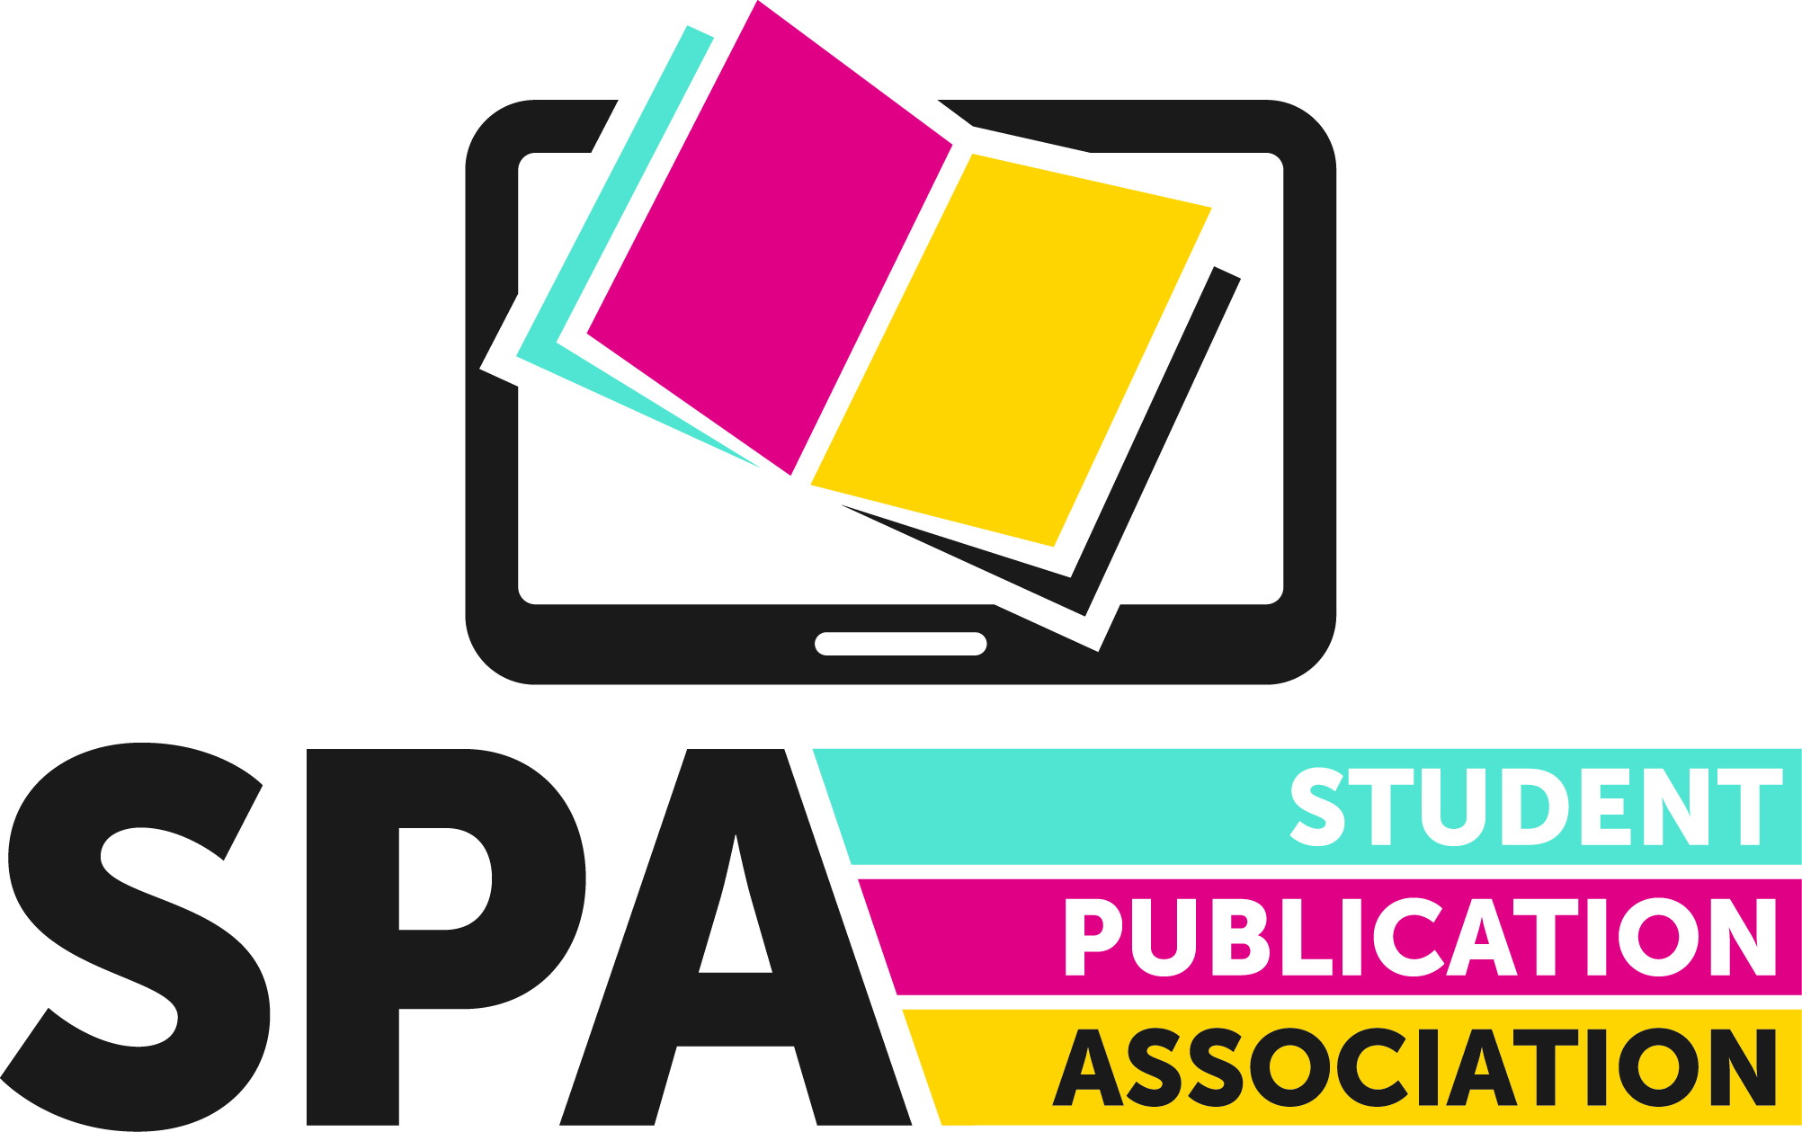

National Awards Entry Form

Name:

Publication:

Category:

Attached Documents:

Contact Email:

Role at Publication:

Twitter Handle:

To enter the awards, please email this form, along with any other supporting documents, to awards@spajournalism.com by 11.59pm on Sunday, February 28th.

The subject line of the email should be ‘NOMINATION: [PUBLICATION NAME] [AWARD CATEGORY HERE]’

All supporting material should be clearly marked with your publication name and the award category, and all attachments should be sent in one email.

All submissions should be in .pdf, .doc or .docx format, or .jpg or .png for images.

Full rules for the awards can be found at www.spajournalism.com.

Should you have any questions about the awards, please contact us via awards@spajournalism.com, or tweet us @SPAJournalism.

By filling in this form you confirm your publication is a member of the SPA - non members will be disqualified.

